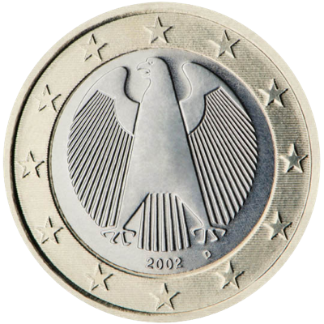

**Congrats! You win this round**

**You**

**Computer**